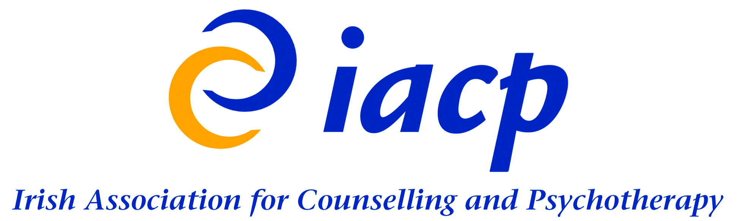

Research Committee

High Level Summary of Strategic Goals 2021-2025

Executive Summary

The IACP Research Strategy aims to set out a vision with overall high-level strategies, tactics and projects designed to address these goals for the next four years (2021-2025). This plan is designed to aid the further development of a research function and the promotion of a research culture across the organisation, in support of the overall IACP Strategic Plan.

Research Committee Mission Statement

To foster, advocate for and embed a research culture within the IACP and the profession by commissioning, supporting, collaborating on, synthesising, and disseminating research that informs member practice, accreditation, and public policymaking.

Strategic Goals 2021-2025 – High Level Summary

Strategy 1: Advise on research issues and policies relating to research in counselling/psychotherapy and the mental health field.
This strategy aims to advance understanding of research in the counselling/psychotherapy and mental health field. It will address key considerations and issues relating to research among counsellors/psychotherapists as identified from various sources. It will explore themes such as therapist engagement with research, how to use research, how to conduct research and practical ethical and methodological implications. The outcome of this strategy will include guidance documents, policies, and helpful tools for counselling/psychotherapy research.

Strategy 2: Identify and address research challenges that members encounter.
This strategy aims to understand key challenges and barriers to research within IACP membership and to identify practical research resources designed to improve clinical practice (evidence-based practice and practice-based evidence). The action arising from this goal will be twofold; a member’s survey with a focus on identifying research challenges and to provide membership resources on process and outcome measures which members can implement in clinical practice.

Strategy 3: Synthesise knowledge and disseminate research findings to encourage public debate, member practice and education about counselling and psychotherapy.
Though significant bodies of research are available, this knowledge is often difficult to access, hard to understand and findings are not always aligned to practice. This goal will aim to increase the impact of existing research by synthesising knowledge and assisting with the dissemination of results from key IACP supported research projects to inform national discussion and public debate. It will also consider ways to maximise dissemination of research to inform member practice using innovative and accessible methods such as videos, animations, Podcasts.

Strategy 4: Develop new and existing resources relating to IACP research strategy, policy, and the code of ethics.
Two areas of attention have been identified for this strategy; to develop appropriate research ethics resources in line with the IACP Code of Ethics and Practice and to promote existing research related member resources while developing several new resources to enhance practice and drive member engagement with research.

Strategy 5: Create and cultivate research networks both nationally and internationally and form links with other relevant committees.
This long-range strategy emanates from the knowledge that research does not exist in a vacuum but rather encompasses a range of contexts including universities, colleges, national and international partners etc. This strategy will encourage and support collaboration by building on existing IACP partnerships and seeking out and developing further partnerships with research stakeholders, institutions, agencies, and policy makers to benefit members who are planning to undertake research or build additional skills.

Strategy 6: Advise on the standard of research education for accredited courses and to encourage greater emphasis on research in training and training in research.
Although the IACP does not currently have a basic standard for research education as part of its course accreditation requirements, it recognises the importance of research in training and training in research. In order to further support, this strategy will identify and share sources of research knowledge to include textbooks; baseline research competencies for therapist training and developing research skills CPD.

Strategy 7: Encourage and embed a research culture within IACP and the Profession.
This long-range strategy is derived from the knowledge that outside of training, engagement with research is generally low across the counselling/psychotherapy profession.
This strategy will focus on embedding a culture of research – reflective of IACP’s values - among our membership. Several key performance indicators will be derived to evaluate and measure research engagement across our membership. Research excellence will also be fostered and celebrated through specific annual awards.

Strategy 8: Develop a specific research agenda. This strategy will align the work of the research committee with the IACP Strategic Plan 2021-2025 by identifying short-term, medium-term, and long-term projects related to the seven other strategic objectives outlined in this document.

